19.62: a)

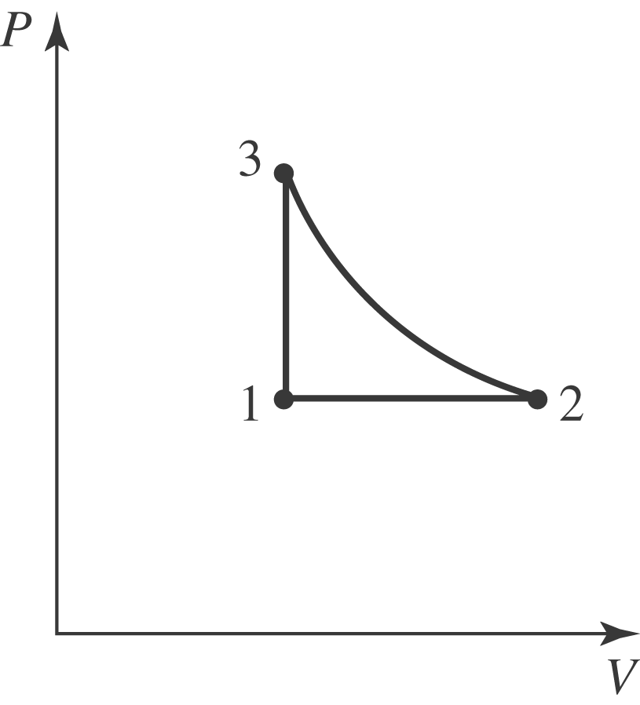

b) The isobaric process doubles the temperature to 710 K, and this must be the temperature of the isothermal process. c) After the isothermal process, the oxygen is at its original volume but twice the original temperature, so the pressure is twice the original pressure, 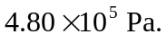 d) Break the process into three steps.
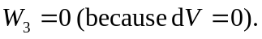
Thus, 

